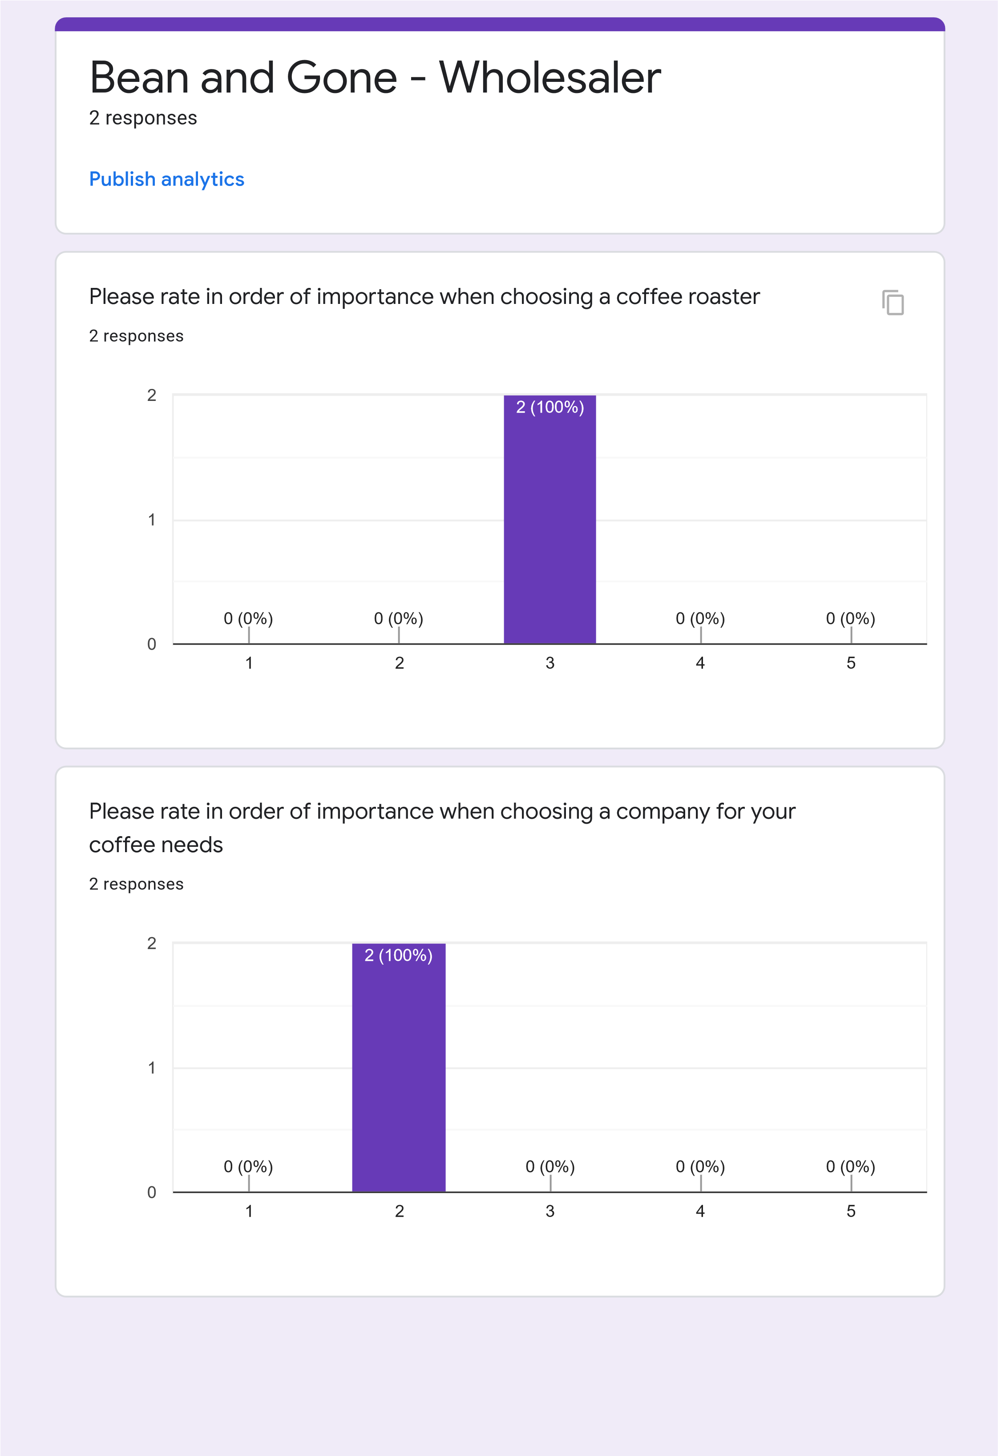

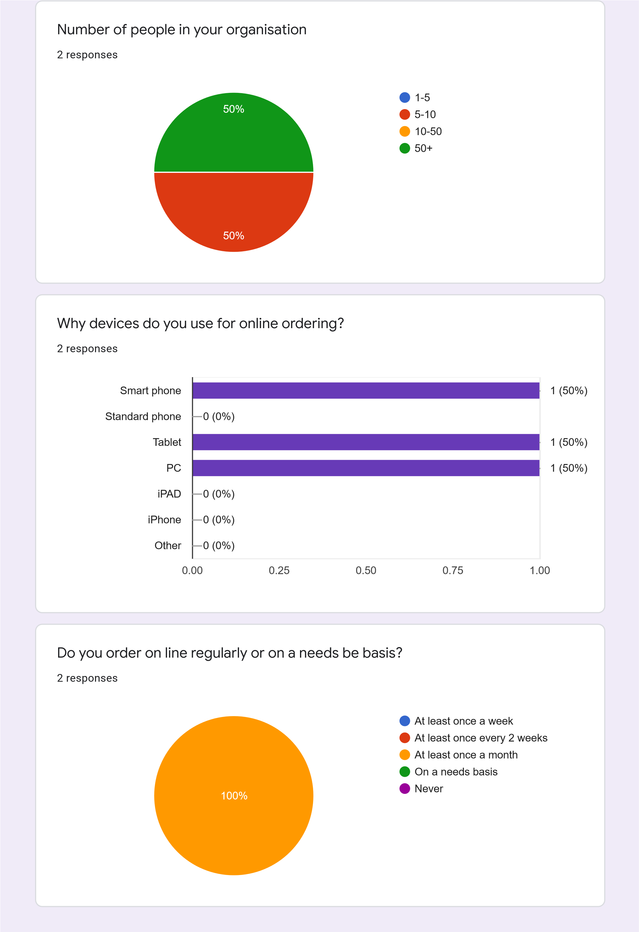

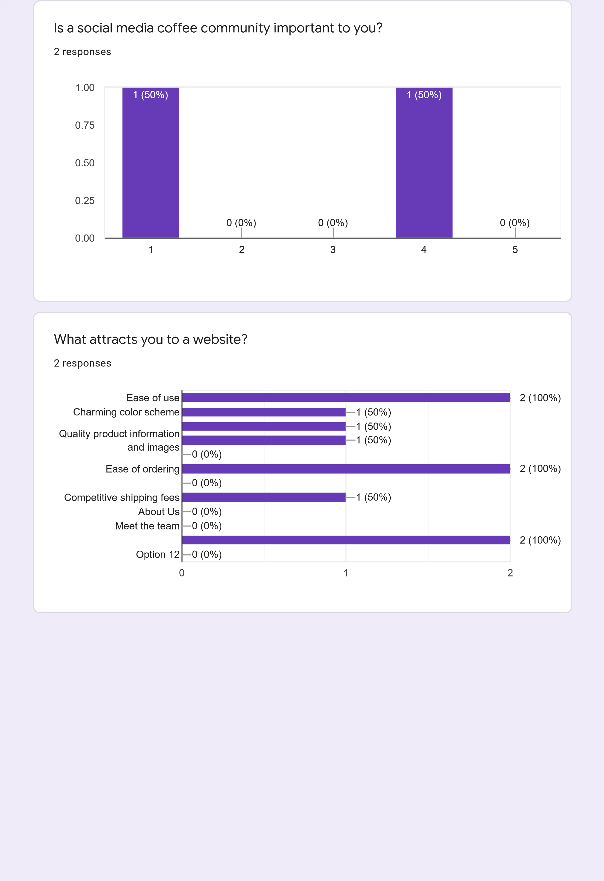

Which colour would your prefer to see in a webpage?

responses

2

Do you prefer dark mode of light mode?

responses

2

1

2

3

4

5

0.00

0.25

0.50

0.75

1.00

)

(0%

0

(50%

)

1

)

(0%

0

)

(0%

0

)

(50%

1

Dark mode (gray/black)

Light mode (white/light gray)

100

%

